GIMP: A Free Alternate to Photoshop!

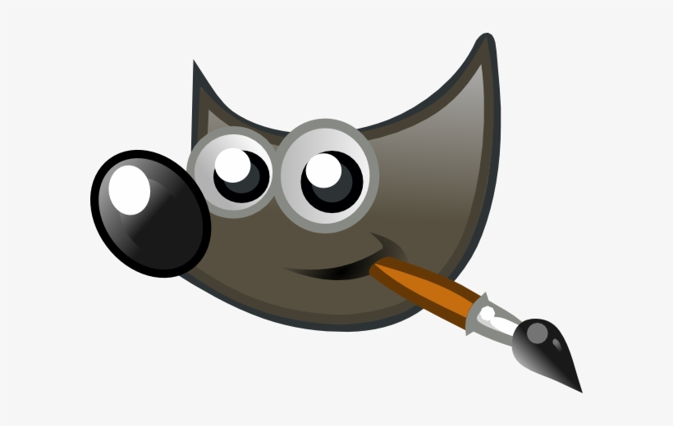

**VERDICT:** Gimp is a powerful image manipulation software, available for free to use on Windows, Mac OS, Linux, Android, and iOS. But is it powerful enough to replace Adobe Photoshop?

**Pros:**

1. User-friendly interface and easy to learn
2. Packed with features for digital image editing
3. User can add plug-ins
4. Support for all the image file types whether it’s RAW or PSD(Photoshop format)
5. Available for most types of OS
6. Runs very smooth even on low-end PCs
7. Most Importantly, It’s Free!

**Cons:**

1. Mobile and Online versions still have some bugs
2. Doesn’t have as many features as Photoshop offers
3. Suitable for Image Editing but not for Designing purposes

**Conclusion:** GIMP can be a very good alternative if you don’t want to pay 10$ per month to Adobe just to edit some of your images for social media. However, GIMP is still not perfect to be a substitute for the designers who expect an overall great designing experience.

**P.S.=** I wrote this short description of an image manipulating software ‘GIMP’ as it will help you to judge me more efficiently. I tried to keep it as short and informative as possible. I can write articles in as many words as you want me to. I could have written about its open-source benefits and how we can add features through Python but I thought that would not be relevant for normal users.